**PL/SQL TASKS**

**DONE BY,**

**P.DILIPKUMAR**

**Task 1 (Create Table, Insert Data to Table, Write Queries)**

Create the below table.

Policy Number Varchar2(20)

Plan Code Varchar2(10)

Age Number

Sum Assured Number

Premium Number

Start Date Date

End Date Date

Insert below data to the table.

|  |  |  |  |  |  |  |
| --- | --- | --- | --- | --- | --- | --- |
| **Policy Number** | **Plan Code** | **Age** | **Sum Assured** | **Premium** | **Start Date** | **End Date** |
| POL_1 | P1 | 30 | 50000 | 500 | 01/01/2020 | 31/12/2020 |
| POL_2 | P1 | 32 | 80000 | 800 | 05-Jan-2020 | 04-Jan-2021 |
| POL_3 | P2 | 40 | 100000 | 100 | 01-02-2020 | 31-01-2020 |
| POL_4 | P1 | 38 | 250000 | 2500 | 15-02-2020 | 14-02-2020 |
| PL_5 | P2 | 41 | 700000 | 700 | 21st Jan 2020 | 20th Jan 2021 |

**Create a table Insurance**

DROP TABLE INSURANCE;

CREATE TABLE INSURANCE (

POLICY_NUMBER VARCHAR2(10),

PLAN_CODE VARCHAR2(10),

AGE NUMBER,

SUM_ASSURED NUMBER,

PREMIUM NUMBER,

START_DATE DATE,

END_DATE DATE

);

**Insert record into a insurance table**

INSERT INTO INSURANCE(POLICY_NUMBER,PLAN_CODE,AGE,SUM_ASSURED,PREMIUM,START_DATE,END_DATE) VALUES('POL_1' ,'P1' ,30 ,50000, 500, '01-JAN-2020', '31-DEC-2020');

INSERT INTO INSURANCE(POLICY_NUMBER,PLAN_CODE,AGE,SUM_ASSURED,PREMIUM,START_DATE,END_DATE) VALUES('POL_2' ,'P1' ,32 ,80000 ,800 ,'05-JAN-2020', '04-JAN-2021');

INSERT INTO INSURANCE(POLICY_NUMBER,PLAN_CODE,AGE,SUM_ASSURED,PREMIUM,START_DATE,END_DATE) VALUES('POL_3' ,'P2' ,40 ,100000 ,100 ,'01-FEB-2020', '31-JAN-2020');

INSERT INTO INSURANCE(POLICY_NUMBER,PLAN_CODE,AGE,SUM_ASSURED,PREMIUM,START_DATE,END_DATE) VALUES('POL_4' ,'P1',38 ,250000 ,2500 ,'15-FEB-2020' ,'14-FEB-2021');

INSERT INTO INSURANCE(POLICY_NUMBER,PLAN_CODE,AGE,SUM_ASSURED,PREMIUM,START_DATE,END_DATE) VALUES('PL_5',' P2', 41, 700000, 700 ,'21-JAN- 2020', '20-JAN-2021');

SELECT * FROM INSURANCE;

ALTER TABLE INSURANCE ADD CONSTRAINTS INSURANCE_PK PRIMARY KEY(POLICY_NUMBER);

DESC INSURANCE;

**Write Queries for the below:-**

|  |  |
| --- | --- |
| **1** | Plan Code Wise Policy Count |
| 2 | Plan Code Wise Total Premium, Total Sum Assured |
| 3 | Find policies with age between 30 and 40 |
| 4 | Find Policies with policy number starting with PL |
| 5 | Select Policies age wise in descending order |
| 6 | Plan Code wise count of policies where age greater than 30 |
| 7 | Find policies with start date in January |
| 8 | Select policies premium wise ascending, sum assured wise descending |
| 9 | Plan Code wise Total Premium greater than 1000 |
| 10 | Plan Code Wise Total Premium less than 3000 and Total Sum Assured greater than 50000 |
|  |  |

# /*QUERIES*/

1. **Plan Code Wise Policy Count**

**SQL Code:**

SELECT PLAN_CODE,COUNT(POLICY_NUMBER) FROM INSURANCE

GROUP BY PLAN_CODE

ORDER BY PLAN_CODE;

**Plan Code Wise Policy Count using PL/SQL Cursors**

DECLARE

v_plancode INSURANCE.PLAN_CODE%TYPE;

v_count NUMBER;

CURSOR v_insur_cur IS SELECT PLAN_CODE,COUNT(*)

FROM INSURANCE

GROUP BY PLAN_CODE

ORDER BY PLAN_CODE;

BEGIN

OPEN v_insur_cur;

LOOP

FETCH v_insur_cur INTO v_plancode, v_count;

EXIT WHEN v_insur_cur%NOTFOUND;

DBMS_OUTPUT.PUT_LINE('PLAN CODE: '||v_plancode);

DBMS_OUTPUT.PUT_LINE('POLICY COUNT: '||v_count);

DBMS_OUTPUT.PUT_LINE(' ');

END LOOP;

CLOSE v_insur_cur;

END;

**Plan Code Wise Policy Count using PL/SQL Cursor For loop**

DECLARE

CURSOR v_insur_cur IS SELECT PLAN_CODE,COUNT(*) AS "POLICY_COUNT"

FROM INSURANCE

GROUP BY PLAN_CODE

ORDER BY PLAN_CODE;

BEGIN

FOR insurance_rec IN v_insur_cur

LOOP

EXIT WHEN v_insur_cur%NOTFOUND;

DBMS_OUTPUT.PUT_LINE('PLAN CODE: '||insurance_rec.PLAN_CODE);

DBMS_OUTPUT.PUT_LINE('POLICY COUNT: '||insurance_rec.POLICY_COUNT);

DBMS_OUTPUT.PUT_LINE(' ');

END LOOP;

END;

**Result:**

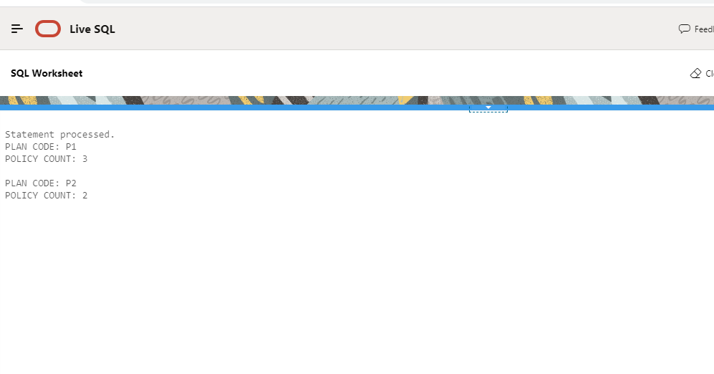

1. **Plan Code Wise Total Premium, Total Sum Assured**

**SQL Code:**

SELECT PLAN_CODE,SUM(PREMIUM),SUM(SUM_ASSURED)

FROM INSURANCE

GROUP BY PLAN_CODE

ORDER BY PLAN_CODE;

**Plan Code Wise Total Premium, Total Sum Assured using PL/SQL Cursor**

DECLARE

v_plancode INSURANCE.PLAN_CODE%TYPE;

v_totalsumassured NUMBER;

v_totalpremium NUMBER;

CURSOR v_insur_cur IS SELECT PLAN_CODE,SUM(PREMIUM),SUM(SUM_ASSURED)

FROM INSURANCE

GROUP BY PLAN_CODE

ORDER BY PLAN_CODE;

BEGIN

OPEN v_insur_cur;

LOOP

FETCH v_insur_cur INTO v_plancode,v_totalpremium,v_totalsumassured;

EXIT WHEN v_insur_cur%NOTFOUND;

DBMS_OUTPUT.PUT_LINE('PLAN CODE: '||v_plancode);

DBMS_OUTPUT.PUT_LINE('TOTAL PREMIUM : '||v_totalpremium);

DBMS_OUTPUT.PUT_LINE('TOTAL SUM ASSURED : '||v_totalsumassured);

DBMS_OUTPUT.PUT_LINE(' ');

END LOOP;

CLOSE v_insur_cur;

END;

**Plan Code Wise Total Premium, Total Sum Assured using PL/SQL Cursor For loop**

DECLARE

CURSOR v_insur_cur IS SELECT PLAN_CODE,SUM(PREMIUM) AS "TOTAL_PREMIUM",SUM(SUM_ASSURED) AS "TOTAL_ASSUERD"

FROM INSURANCE

GROUP BY PLAN_CODE

ORDER BY PLAN_CODE;

BEGIN

FOR insur_rec IN v_insur_cur

LOOP

EXIT WHEN v_insur_cur%NOTFOUND;

DBMS_OUTPUT.PUT_LINE('PLAN CODE: '||insur_rec.PLAN_CODE);

DBMS_OUTPUT.PUT_LINE('TOTAL PREMIUM: '||insur_rec.TOTAL_PREMIUM);

DBMS_OUTPUT.PUT_LINE('TOTAL SUM ASSURED: '||insur_rec.TOTAL_ASSUERD);

DBMS_OUTPUT.PUT_LINE(' ');

END LOOP;

END;

**Result:**

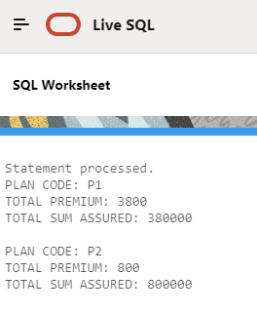

1. **Find policies with age between 30 and 40**

**SQL code:**

SELECT POLICY_NUMBER, AGE

FROM INSURANCE

WHERE AGE BETWEEN 30 AND 40;

**Find policies with age between 30 and 40 using PL/SQL Cursor**

DECLARE

v_policynumber INSURANCE.POLICY_NUMBER%TYPE;

v_age INSURANCE.AGE%TYPE;

CURSOR v_insur_cur IS SELECT POLICY_NUMBER, AGE

FROM INSURANCE

WHERE AGE BETWEEN 30 AND 40;

BEGIN

OPEN v_insur_cur ;

LOOP

FETCH v_insur_cur INTO v_policynumber,v_age;

EXIT WHEN v_insur_cur%NOTFOUND;

DBMS_OUTPUT.PUT_LINE('POLICY NUMBER: '||v_policynumber);

DBMS_OUTPUT.PUT_LINE('AGE : '||v_age);

DBMS_OUTPUT.PUT_LINE(' ');

END LOOP;

CLOSE v_insur_cur ;

END;

**Find policies with age between 30 and 40 using PL/SQL Cursor For loop**

DECLARE

CURSOR v_insur_cur IS SELECT POLICY_NUMBER, AGE

FROM INSURANCE

WHERE AGE BETWEEN 30 AND 40;

BEGIN

FOR insur_rec IN v_insur_cur

LOOP

EXIT WHEN v_insur_cur%NOTFOUND;

DBMS_OUTPUT.PUT_LINE('POLICY NUMBER: '||insur_rec.POLICY_NUMBER);

DBMS_OUTPUT.PUT_LINE('AGE : '||insur_rec.AGE);

DBMS_OUTPUT.PUT_LINE(' ');

END LOOP;

END;

**Result:**

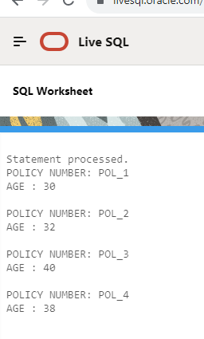

1. **Find Policies with policy number starting with PL**

**SQL Code:**

SELECT POLICY_NUMBER FROM INSURANCE

WHERE POLICY_NUMBER LIKE'PL%';

**Find Policies with policy number starting with PL using PL/SQL Cursor**

DECLARE

v_policynumber INSURANCE.POLICY_NUMBER%TYPE;

CURSOR v_insur_cur IS SELECT POLICY_NUMBER FROM INSURANCE

WHERE POLICY_NUMBER LIKE'PL%';

BEGIN

OPEN v_insur_cur ;

LOOP

FETCH v_insur_cur INTO v_policynumber;

EXIT WHEN v_insur_cur%NOTFOUND;

DBMS_OUTPUT.PUT_LINE('POLICY NUMBER: '||v_policynumber);

END LOOP;

CLOSE v_insur_cur ;

END;

**Find Policies with policy number starting with PL using PL/SQL Cursor For loop**

DECLARE

CURSOR v_insur_cur IS SELECT POLICY_NUMBER

FROM INSURANCE

WHERE POLICY_NUMBER LIKE '%PL%';

BEGIN

FOR insur_rec IN v_insur_cur

LOOP

EXIT WHEN v_insur_cur%NOTFOUND;

DBMS_OUTPUT.PUT_LINE('POLICY NUMBER: '||insur_rec.POLICY_NUMBER);

END LOOP;

END;

**Result:**

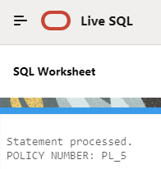

1. **Select Policies age wise in descending order**

**SQL code:**

SELECT POLICY_NUMBER,AGE

FROM INSURANCE

ORDER BY AGE DESC;

**Select Policies age wise in descending order using PL/SQL Cursor**

DECLARE

v_policynumber INSURANCE.POLICY_NUMBER%TYPE;

v_age INSURANCE.AGE%TYPE;

CURSOR v_insur_cur IS SELECT POLICY_NUMBER,AGE

FROM INSURANCE

ORDER BY AGE DESC;

BEGIN

OPEN v_insur_cur;

LOOP

FETCH v_insur_cur INTO v_policynumber,v_age;

EXIT WHEN v_insur_cur%NOTFOUND;

DBMS_OUTPUT.PUT_LINE('POLICY NUMBER: '||v_policynumber);

DBMS_OUTPUT.PUT_LINE('AGE : '||v_age);

DBMS_OUTPUT.PUT_LINE(' ');

END LOOP;

CLOSE v_insur_cur;

END;

**Select Policies age wise in descending order using PL/SQL Cursor For loop**

DECLARE

CURSOR v_insur_cur IS SELECT POLICY_NUMBER,AGE

FROM INSURANCE

ORDER BY AGE DESC;

BEGIN

FOR ins_rec IN v_insur_cur

LOOP

EXIT WHEN v_insur_cur%NOTFOUND;

DBMS_OUTPUT.PUT_LINE('POLICY NUMBER: '||ins_rec.POLICY_NUMBER);

DBMS_OUTPUT.PUT_LINE('AGE : '||ins_rec.AGE);

DBMS_OUTPUT.PUT_LINE(' ');

END LOOP;

END;

**Result:**

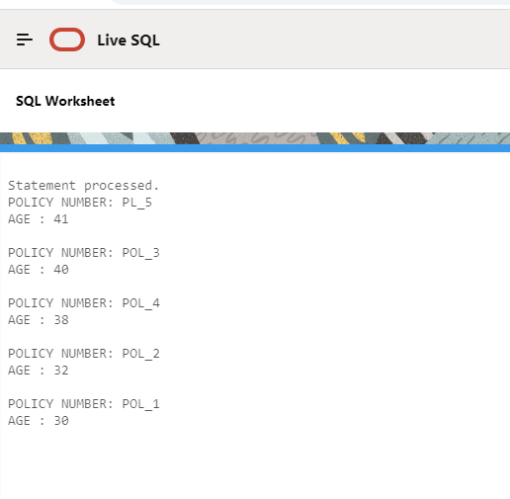

1. **Plan Code wise count of policies where age greater than 30**

**SQL Code:**

SELECT PLAN_CODE, COUNT (POLICY_NUMBER) AS POLICY_COUNT FROM INSURANCE

WHERE AGE>30

GROUP BY PLAN_CODE

ORDER BY PLAN_CODE;

**Plan Code wise count of policies where age greater than 30 using PL/SQL Cursor**

DECLARE

v_plancode INSURANCE.PLAN_CODE%TYPE;

v_count NUMBER;

CURSOR v_insur_cur IS SELECT PLAN_CODE, COUNT (POLICY_NUMBER)

FROM INSURANCE

WHERE AGE>30

GROUP BY PLAN_CODE

ORDER BY PLAN_CODE;

BEGIN

OPEN v_insur_cur;

LOOP

FETCH v_insur_cur INTO v_plancode,v_count;

EXIT WHEN v_insur_cur%NOTFOUND;

DBMS_OUTPUT.PUT_LINE('PLAN CODE : '||v_plancode);

DBMS_OUTPUT.PUT_LINE(COUNT : '||v_count);

DBMS_OUTPUT.PUT_LINE(' ');

END LOOP;

CLOSE v_insur_cur;

END;

**Plan Code wise count of policies where age greater than 30 using PL/SQL Cursor For loop**

DECLARE

CURSOR v_insur_cur IS SELECT PLAN_CODE, COUNT (POLICY_NUMBER) AS "POLICY_COUNT"

FROM INSURANCE

WHERE AGE>30

GROUP BY PLAN_CODE

ORDER BY PLAN_CODE;

BEGIN

FOR ins_rec IN v_insur_cur

LOOP

EXIT WHEN v_insur_cur%NOTFOUND;

DBMS_OUTPUT.PUT_LINE('PLAN CODE: '||ins_rec.PLAN_CODE);

DBMS_OUTPUT.PUT_LINE('POLICY COUNT : '||ins_rec.POLICY_COUNT);

DBMS_OUTPUT.PUT_LINE(' ');

END LOOP;

END;

**Result:**

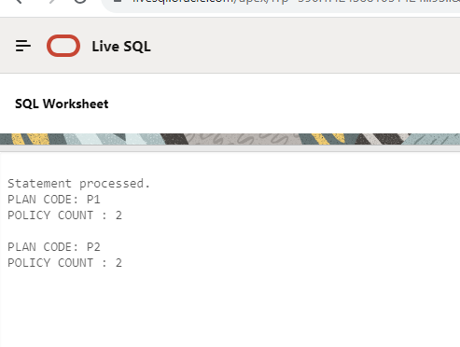

1. **Find policies with start date in January**

**SQL code:**

SELECT POLICY_NUMBER, START_DATE FROM INSURANCE

WHERE START_DATE LIKE '%JAN%';

**Find policies with start date in January using PL/SQL cursor**

DECLARE

v_policynumber INSURANCE.POLICY_NUMBER%TYPE;

v_startdate INSURANCE.START_DATE%TYPE;

CURSOR v_insur_cur IS SELECT POLICY_NUMBER, START_DATE FROM INSURANCE

WHERE START_DATE LIKE '%JAN%';

BEGIN

OPEN v_insur_cur;

LOOP

FETCH v_insur_cur INTO v_policynumber,v_startdate;

EXIT WHEN v_insur_cur%NOTFOUND;

DBMS_OUTPUT.PUT_LINE('POLICY NUMBER: '||v_policynumber);

DBMS_OUTPUT.PUT_LINE('START DATE: '||v_startdate);

DBMS_OUTPUT.PUT_LINE(' ');

END LOOP;

CLOSE v_insur_cur;

END;

**Find policies with start date in January using PL/SQL cursor**

DECLARE

CURSOR v_insur_cur IS SELECT POLICY_NUMBER, START_DATE FROM INSURANCE

WHERE START_DATE LIKE '%JAN%';

BEGIN

FOR ins_rec IN v_insur_cur

LOOP

EXIT WHEN v_insur_cur%NOTFOUND;

DBMS_OUTPUT.PUT_LINE('POLICY NUMBER: '||ins_rec.POLICY_NUMBER);

DBMS_OUTPUT.PUT_LINE('START DATE: '||ins_rec.START_DATE);

DBMS_OUTPUT.PUT_LINE(' ');

END LOOP;

END;

**Result:**

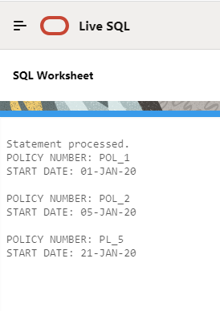

1. **Select policies premium wise ascending, sum assured wise descending**

**SQL code:**

SELECT POLICY_NUMBER, PREMIUM, SUM_ASSURED FROM INSURANCE

ORDER BY PREMIUM, SUM_ASSURED DESC;

**Select policies premium wise ascending, sum assured wise descending using PL/SQL cursor**

DECLARE

v_policynumber INSURANCE.POLICY_NUMBER%TYPE;

v_premium INSURANCE.PREMIUM %TYPE;

v_summassured INSURANCE.SUM_ASSURED%TYPE;

CURSOR v_ins_cur IS SELECT POLICY_NUMBER,PREMIUM,SUM_ASSURED

FROM INSURANCE

ORDER BY PREMIUM ASC,

SUM_ASSURED DESC;

BEGIN

OPEN v_ins_cur;

LOOP

FETCH v_ins_cur INTO v_policynumber,v_premium,v_summassured ;

EXIT WHEN v_ins_cur%NOTFOUND;

DBMS_OUTPUT.PUT_LINE('POLICY NUMBER : '||v_policynumber);

DBMS_OUTPUT.PUT_LINE('PREMIUM : '||v_premium);

DBMS_OUTPUT.PUT_LINE('SUM ASSURED: '||v_summassured);

DBMS_OUTPUT.PUT_LINE(' ');

END LOOP;

CLOSE v_ins_cur;

END;

**Select policies premium wise ascending, sum assured wise descending using PL/SQL cursor for loop**

DECLARE

CURSOR v_ins_cur IS SELECT POLICY_NUMBER,PREMIUM,SUM_ASSURED

FROM INSURANCE

ORDER BY PREMIUM ASC,

SUM_ASSURED DESC;

BEGIN

FOR ins_rec IN v_ins_cur

LOOP

EXIT WHEN v_ins_cur%NOTFOUND;

DBMS_OUTPUT.PUT_LINE('POLICY NUMBER : '||ins_rec.POLICY_NUMBER);

DBMS_OUTPUT.PUT_LINE('PREMIUM : '||ins_rec.PREMIUM);

DBMS_OUTPUT.PUT_LINE('SUM ASSURED: '||ins_rec.SUM_ASSURED);

DBMS_OUTPUT.PUT_LINE(' ');

END LOOP;

END;

**Result:**

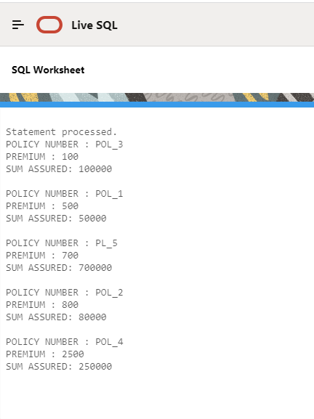

1. **Plan Code wise Total Premium greater than 1000**

**SQL code:**

SELECT PLAN_CODE, SUM (PREMIUM) AS TOTAL_PREMIUM FROM INSURANCE

GROUP BY PLAN_CODE

HAVING SUM (PREMIUM)>1000

ORDER BY PLAN_CODE;

**Plan Code wise Total Premium greater than 1000 using PL/SQL cursor**

DECLARE

v_plancode INSURANCE.PLAN_CODE%TYPE;

v_totalprem NUMBER;

CURSOR v_ins_cur IS SELECT PLAN_CODE, SUM (PREMIUM)

FROM INSURANCE

GROUP BY PLAN_CODE

HAVING SUM (PREMIUM)>1000

ORDER BY PLAN_CODE;

BEGIN

OPEN v_ins_cur;

LOOP

FETCH v_ins_cur INTO v_plancode,v_totalprem;

EXIT WHEN v_ins_cur%NOTFOUND;

DBMS_OUTPUT.PUT_LINE('PLAN CODE: '||v_plancode);

DBMS_OUTPUT.PUT_LINE('TOTAL PREMIUM : '||v_totalprem);

DBMS_OUTPUT.PUT_LINE(' ');

END LOOP;

CLOSE v_ins_cur;

END;

**Plan Code wise Total Premium greater than 1000 using PL/SQL cursor for loop**

DECLARE

CURSOR v_ins_cur IS SELECT PLAN_CODE, SUM (PREMIUM) AS "TOTAL_PREMIUM"

FROM INSURANCE

GROUP BY PLAN_CODE

HAVING SUM (PREMIUM)>1000

ORDER BY PLAN_CODE;

BEGIN

FOR ins_rec IN v_ins_cur

LOOP

EXIT WHEN v_ins_cur%NOTFOUND;

DBMS_OUTPUT.PUT_LINE('PLAN CODE: '||ins_rec.PLAN_CODE);

DBMS_OUTPUT.PUT_LINE('TOTAL PREMIUM : '||ins_rec.TOTAL_PREMIUM);

DBMS_OUTPUT.PUT_LINE(' ');

END LOOP;

END;

**Result:**

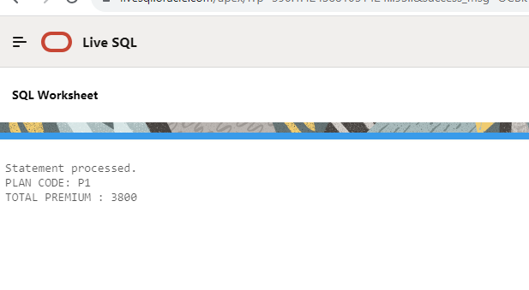

1. **Plan Code Wise Total Premium less than 3000 and Total Sum Assured greater than 50000**

**SQL code:**

SELECT PLAN_CODE,SUM(PREMIUM),SUM(SUM_ASSURED)

FROM INSURANCE

GROUP BY PLAN_CODE

HAVING SUM(PREMIUM)<3000 AND SUM(SUM_ASSURED)>50000

ORDER BY PLAN_CODE;

**Plan Code Wise Total Premium less than 3000 and Total Sum Assured greater than 50000 using PL/SQL cursor**

DECLARE

v_plancode INSURANCE.PLAN_CODE%TYPE;

v_totalsumassured NUMBER;

v_totalprem NUMBER;

CURSOR v_ins_cur IS SELECT PLAN_CODE,SUM(PREMIUM),SUM(SUM_ASSURED)

FROM INSURANCE

GROUP BY PLAN_CODE

HAVING SUM(PREMIUM)<3000 AND SUM(SUM_ASSURED)>50000

ORDER BY PLAN_CODE;

BEGIN

OPEN v_ins_cur ;

LOOP

FETCH v_ins_cur INTO v_plancode,v_totalsumassured,v_totalprem;

EXIT WHEN v_ins_cur%NOTFOUND;

DBMS_OUTPUT.PUT_LINE('PLAN CODE: '||v_plancode);

DBMS_OUTPUT.PUT_LINE('TOTAL SUM ASSURED : '||v_totalsumassured);

DBMS_OUTPUT.PUT_LINE('TOTAL PREMIUM : '||v_totalprem);

END LOOP;

CLOSE v_ins_cur ;

END;

**Plan Code Wise Total Premium less than 3000 and Total Sum Assured greater than 50000 using PL/SQL cursor for loop**

DECLARE

CURSOR v_ins_cur IS SELECT PLAN_CODE,SUM(PREMIUM) AS "TOT_PREM",SUM(SUM_ASSURED) AS "TOT_SUM_ASSURED"

FROM INSURANCE

GROUP BY PLAN_CODE

HAVING SUM(PREMIUM)<3000 AND SUM(SUM_ASSURED)>50000

ORDER BY PLAN_CODE;

BEGIN

FOR ins_rec IN v_ins_cur

LOOP

EXIT WHEN v_ins_cur%NOTFOUND;

DBMS_OUTPUT.PUT_LINE('PLAN CODE: '||ins_rec.PLAN_CODE);

DBMS_OUTPUT.PUT_LINE('TOTAL SUM ASSURED : '||ins_rec.TOT_SUM_ASSURED);

DBMS_OUTPUT.PUT_LINE('TOTAL PREMIUM : '||ins_rec.TOT_PREM);

END LOOP;

END;

**Result:**

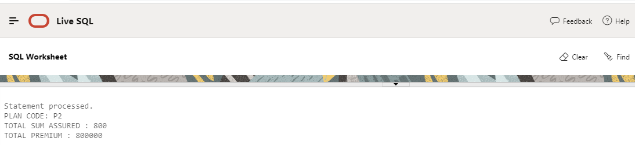

**Task 2 (Create Tables, Insert Data to Table 1, Write Procedure to Populate Table 2)**

Create 2 tables Class Grade and Student Grade

Table - Class Grade

|  |  |  |  |  |
| --- | --- | --- | --- | --- |
| **Class** | **Mark From** | **Mark To** | | **Grade** |
| 1 | 1 | 39 | | Fail |
| 1 | 40 | 49 | | 3rd Class |
| 1 | 50 | 59 | | 2nd Class |
| 1 | 60 | 79 | | 1st Class |
| 1 | 80 | | 100 | Distinction |
|  |  |  | |  |
| Insert above date into Class Grade table. | | | |  |
| Table – Student Grade | |  | |  |
| **Student** | **Class** | **Mark** | | **Grade** |
|  |  |  | |  |
|  |  |  | |  |
|  |  |  | |  |
|  |  |  | |  |

|  |  |
| --- | --- |
| Write a procedure with input (Student, Class and Mark) | |
| Find the Grade from Class Grade table based on Class & Mark |
| Insert Input data and grade into Student Grade Table |

**PL/SQL code:**

**Create a table class_grade**

DROP TABLE CLASS_GRADE;

CREATE TABLE CLASS_GRADE

(

CLASS NUMBER,

MARK_FROM NUMBER,

MARK_TO NUMBER,

GRADE VARCHAR2(50)

);

**Insert values into the class_grade table**

INSERT INTO CLASS_GRADE(CLASS,MARK_FROM,MARK_TO,GRADE) VALUES (1,1,39,'FAIL');

INSERT INTO CLASS_GRADE(CLASS,MARK_FROM,MARK_TO,GRADE) VALUES (1,40,49,'3RD CLASS');

INSERT INTO CLASS_GRADE(CLASS,MARK_FROM,MARK_TO,GRADE) VALUES (1,50,59,'2ND CLASS');

INSERT INTO CLASS_GRADE(CLASS,MARK_FROM,MARK_TO,GRADE) VALUES (1,60,79,'1ST CLASS');

INSERT INTO CLASS_GRADE(CLASS,MARK_FROM,MARK_TO,GRADE) VALUES (1,80,100,'DISTINCTION');

SELECT * FROM CLASS_GRADE;

DROP TABLE STUDENT_GRADE;

**Create a table student_grade**

CREATE TABLE STUDENT_GRADE

(

STUDENT NUMBER,

CLASS NUMBER,

MARK NUMBER,

GRADE VARCHAR2(50)

);

SELECT * FROM STUDENT_GRADE;

**Create a procedure for finding grade result**

CREATE OR REPLACE PROCEDURE student_mark_procedure(v_student NUMBER,

v_class NUMBER,

v_mark NUMBER

)

AS

v_graderesult VARCHAR2(50);

BEGIN

SELECT GRADE INTO v_graderesult

FROM CLASS_GRADE

WHERE CLASS = v_class

AND MARK_FROM <= v_mark

AND MARK_TO >= v_mark;

INSERT INTO STUDENT_GRADE (STUDENT,CLASS, MARK,GRADE) VALUES (v_student,v_class,v_mark,v_graderesult) ;

EXCEPTION

WHEN NO_DATA_FOUND THEN

DBMS_OUTPUT.PUT_LINE('No data found, please check to the class grade table');

WHEN OTHERS THEN

DBMS_OUTPUT.PUT_LINE('An Error occured...'||SQLERRM);

END student_mark_procedure;

**Execute a procedure**

BEGIN

student_mark_procedure(1701,1,94);

END;

EXEC student_mark_procedure(1702,1,94);

EXEC student_mark_procedure(1703,1,-5);

**Result:**

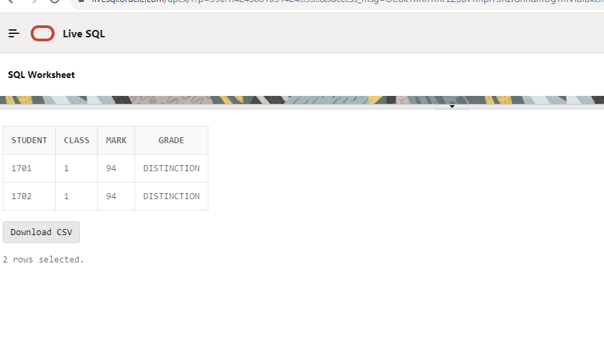

**Task 3 (Create Tables, Insert Data to Table 1, Write Procedure to Populate Table 2)**

Create 2 tables inventory master and inventory purchase

Table - Tbl_inventory_master

|  |  |  |  |  |  |  |  |  |  |  |
| --- | --- | --- | --- | --- | --- | --- | --- | --- | --- | --- |
|  |  |  |  |  |  |  |  |  |  |  |
|  |  |  |  |  |  |  |  |  |  |  |
| **Item Code** | **Item Name** | **Stock** | **Selling Rate** | **Buying Rate** |  |  |  |  |  |  |
| IT01 | Pen | 0 | 10 | 6 |  |  |  |  |  |  |
| IT02 | Pencil | 0 | 5 | 3 |  |  |  |  |  |  |
| IT03 | Eraser | 0 | 3 | 1 |  |  |  |  |  |  |
| IT04 | Scale | 0 | 25 | 15 |  |  |  |  |  |  |
| Create DML Statements to insert the above data to inventory master table.  Table - Tbl_inventory_purchase | | | | | | | | | |  |
| **Item code** | **Purchase date** | **Purchase Qty** | **Selling Rate** | **Purchase Amt** |  |  |  |  |  |  |
|  |  |  |  |  |  |  |  |  |  |  |
|  |  |  |  |  |  |  |  |  |  |  |
|  |  |  |  |  |  |  |  |  |  |  |
|  |  |  |  |  |  |  |  |  |  |  |

Write a Procedure to insert data into inventory purchase table by passing Item Code, Purchase Date and Purchase quantity as parameters.

Before inserting into above table find the selling rate of that item code from tbl_inventory_master and calculate purchase amount (rate * purchase qty)

While Inserting into the above table, insert input data along with selling rate and calculated purchase amount

**Create a table Inventory_master**

DROP TABLE INVENTORY_MASTER;

CREATE TABLE INVENTORY_MASTER

(

ITEM_CODE VARCHAR2(50),

ITEM_NAME VARCHAR2(200),

STOCK NUMBER,

SELLING_RATE NUMBER,

BUYING_RATE NUMBER

);

SELECT * FROM INVENTORY_MASTER;

**Insert values into the table inventory_master**

INSERT INTO INVENTORY_MASTER(ITEM_CODE,ITEM_NAME ,STOCK ,SELLING_RATE ,BUYING_RATE ) VALUES ( 'IT01','Pen',0,10,6);

INSERT INTO INVENTORY_MASTER(ITEM_CODE,ITEM_NAME ,STOCK ,SELLING_RATE ,BUYING_RATE ) VALUES ( 'IT02','PENCIL',0,5,3);

INSERT INTO INVENTORY_MASTER(ITEM_CODE,ITEM_NAME ,STOCK ,SELLING_RATE ,BUYING_RATE ) VALUES ( 'IT04','ERASER',0,3,1);

INSERT INTO INVENTORY_MASTER(ITEM_CODE,ITEM_NAME ,STOCK ,SELLING_RATE ,BUYING_RATE ) VALUES ( 'IT04','SCLAE',0,25,15);

**Create a table Inventory_purchase**

DROP TABLE INVENTORY_PURCHASE;

CREATE TABLE INVENTORY_PURCHASE

(

ITEM_CODE VARCHAR2(50),

PURCHASE_DATE DATE,

PURCHASE_QTY NUMBER,

SELLING_RATE NUMBER,

PURCHASE_AMT NUMBER

);

**Create a procedure to insert inventery_purchase table**

DROP PROCEDURE insert_inventory;

CREATE OR REPLACE PROCEDURE insert_inventory

(

v_itemcode INVENTORY_MASTER.ITEM_CODE%TYPE,

v_purchase_date DATE,

v_purchase_qty NUMBER

)

AS

v_selling_rate NUMBER;

v_purchase_amt NUMBER;

BEGIN

SELECT SELLING_RATE

INTO v_selling_rate

FROM INVENTORY_MASTER

WHERE ITEM_CODE = v_itemcode;

v_purchase_amt := v_selling_rate * v_purchase_qty;

INSERT INTO INVENTORY_PURCHASE (ITEM_CODE,PURCHASE_DATE,PURCHASE_QTY,SELLING_RATE,PURCHASE_AMT) VALUES (v_itemcode,v_purchase_date,v_purchase_qty,v_selling_rate,v_purchase_amt);

END insert_inventory;

**Execute a procedure:**

EXECUTE insert_inventory('IT02',SYSDATE,5);

**Result:**

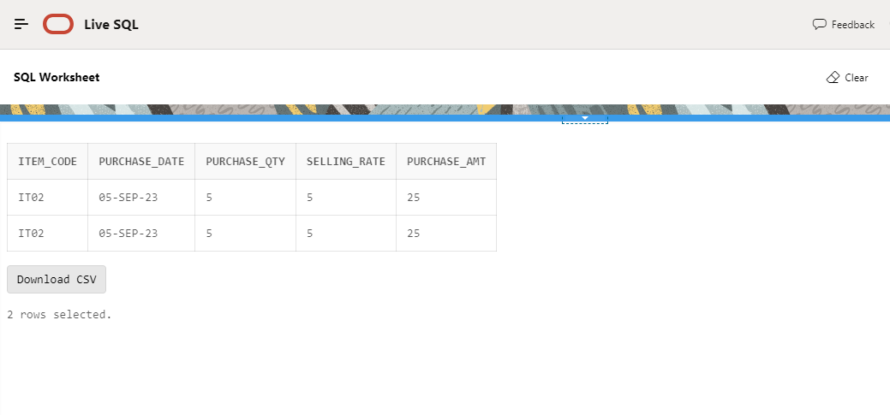

**Task 4 (Create Tables, Write Procedure to Populate both the Tables)**

Create 2 tables card master and card details

**Card Master**

Card ID Varchar2(20)

Card Name Varchar2(100)

Prev Type Varchar2(1)

Prev Amount Number

Curr Type Varchar2(1)

Curr Amount Number

Net Type Varchar2(1)

Net Amount Number

Last_trans_Date Date

**Card Details**

Card ID Varchar2(20)

Type Varchar2(1)

Amount Number

Trans_Date Date

Write a procedure with the following parameters

Card ID, Card Name, Type, Amount, Trans Date

If it is new card ID, a new record should be created in Card Master table.

Prev Type, Prev Amount should be Null.

Current Type, Current Amount should be Type and Amount from Input.

Net Type and Net amount should be Type and Amount from Input.

Last Trans Date should be Trans Date from Input.

Card ID, Type, Amount, Trans date should be inserted into Card details table as it is from Input.

Exec Procedure P1 (C1, ‘John’, D, 1000, ‘10/10/2021’);

Exec Procedure P1 (C2, ‘Raj’, D, 500, ‘12/10/2021’);

Exec Procedure P1 (C3, ‘Williams ‘, C, 100, ‘15/10/2021’);

Above execution, should give the below results in card master and card details tables.

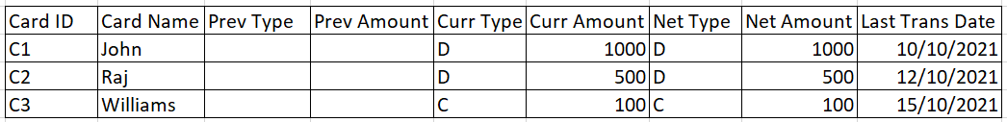

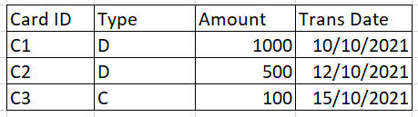

If the card already exists, in card master, data should be inserted as it is in card details table.

In Master existing data should be updated as below:-

Prev Type, Prev Amount, Current Type, Current Amount and Net Type and Net amount should be calculated as the examples shown in the transactions below.

Last Trans Date should be Trans Date from Input.

Exec Procedure P1 (C1, ‘John’, D, 200, ‘15/10/2021’);

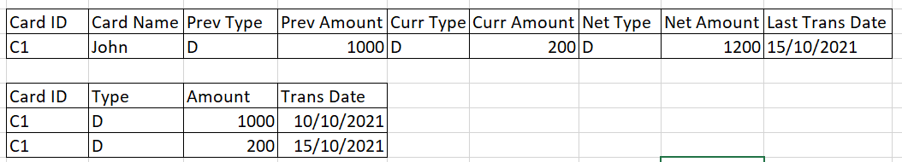

Exec Procedure P1 (C1, ‘John’, D, 500, ‘20/10/2021’);

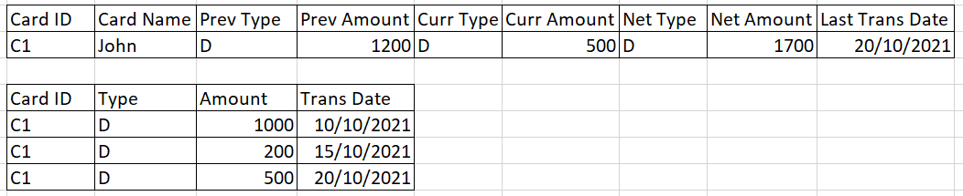

Exec Procedure P1 (C2, ‘Raj’, D, 500, ‘12/10/2021’);

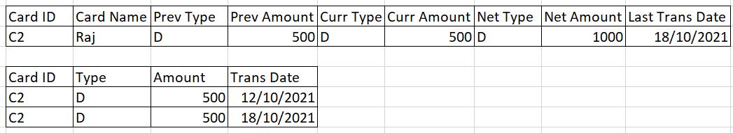

Exec Procedure P1 (C2, ‘Raj’, C, 1000, ‘20/10/2021’);

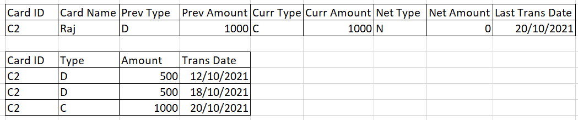

Exec Procedure P1 (C3, ‘Williams ‘, C, 800, ‘22/10/2021’);

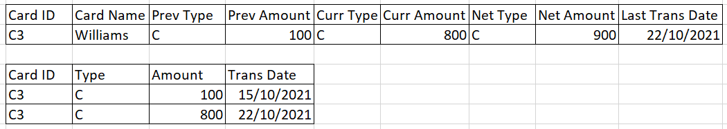

Exec Procedure P1 (C3, ‘Williams ‘, D, 400, ‘25/10/2021’);

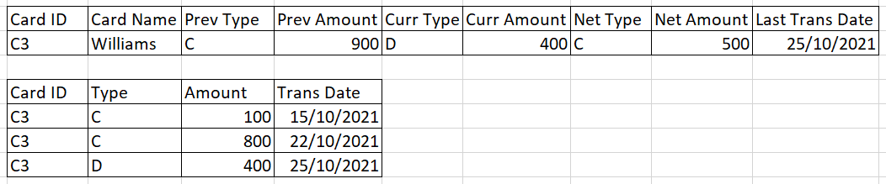

**Create a table card_master**

DROP TABLE CARD_MASTER;

CREATE TABLE CARD_MASTER

(

CARD_ID VARCHAR2(20),

CARD_NAME VARCHAR2(100),

PREV_TPYE VARCHAR2(1),

PREV_AMOUNT NUMBER,

CURR_TYPE VARCHAR2(1),

CURR_AMOUNT NUMBER,

NET_TYPE VARCHAR2(1),

NET_AMOUNT NUMBER,

LAST_TRANS_DATE DATE

);

SELECT * FROM CARD_MASTER;

**Create a table card_details**

DROP TABLE CARD_DETAILS;

CREATE TABLE CARD_DETAILS

(

CARD_ID VARCHAR2(20),

TYPE VARCHAR2(1),

AMOUNT NUMBER,

TRANS_DATE DATE

);

SELECT * FROM CARD_DETAILS;

**Create a procedure for both the tables:**

CREATE OR REPLACE PROCEDURE card_proc (

P_CARD_ID VARCHAR2,

P_CARD_NAME VARCHAR2,

P_TYPE VARCHAR2,

P_AMOUNT NUMBER,

P_TRANS_DATE DATE

)

IS

V_EXISTING_CARD NUMBER;

V_PREV_TYPE VARCHAR2(1);

V_PREV_AMOUNT NUMBER;

V_CURRENT_TYPE VARCHAR2(1);

V_CURRENT_AMOUNT NUMBER;

V_NET_TYPE VARCHAR2(1);

V_NET_AMOUNT NUMBER;

BEGIN

**-- To Check if the card already exists in Card Master table**

SELECT COUNT(*) INTO V_EXISTING_CARD FROM CARD_MASTER WHERE CARD_ID = P_CARD_ID;

IF V_EXISTING_CARD = 0 THEN

**-- Card is new, insert a new record into Card Master table**

INSERT INTO CARD_MASTER (CARD_ID, CARD_NAME, PREV_TPYE, PREV_AMOUNT, CURR_TYPE, CURR_AMOUNT, NET_TYPE, NET_AMOUNT, LAST_TRANS_DATE)

VALUES (P_CARD_ID, P_CARD_NAME, NULL, NULL, P_TYPE, P_AMOUNT, P_TYPE, P_AMOUNT, P_TRANS_DATE);

ELSE

SELECT CURR_TYPE, CURR_AMOUNT INTO V_PREV_TYPE, V_PREV_AMOUNT

FROM CARD_MASTER

WHERE CARD_ID = P_CARD_ID;

V_CURRENT_TYPE := P_TYPE;

V_CURRENT_AMOUNT := P_AMOUNT;

V_NET_TYPE := P_TYPE;

V_NET_AMOUNT := V_PREV_AMOUNT + P_AMOUNT;

**-- Update the record in Card Master table**

UPDATE CARD_MASTER

SET PREV_TPYE = V_PREV_TYPE,

PREV_AMOUNT = V_PREV_AMOUNT,

CURR_TYPE = V_CURRENT_TYPE,

CURR_AMOUNT = V_CURRENT_AMOUNT,

NET_TYPE = V_NET_TYPE,

NET_AMOUNT = V_NET_AMOUNT,

LAST_TRANS_DATE = P_TRANS_DATE

WHERE CARD_ID = P_CARD_ID;

END IF; **-- Insert the transaction details into Card Details table**

INSERT INTO CARD_DETAILS (CARD_ID, TYPE, AMOUNT, TRANS_DATE)

VALUES (P_CARD_ID, P_TYPE, P_AMOUNT, P_TRANS_DATE);

END;

**Executing a Procedure**

EXEC card_proc('C1', 'John', 'D', 1000, TO_DATE('10/10/2021', 'DD/MM/YYYY'));

EXEC card_proc('C2', 'Raj', 'D', 500, TO_DATE('12/10/2021', 'DD/MM/YYYY'));

EXEC card_proc('C3', 'Williams', 'C', 100, TO_DATE('15/10/2021', 'DD/MM/YYYY'));

**Result:**

